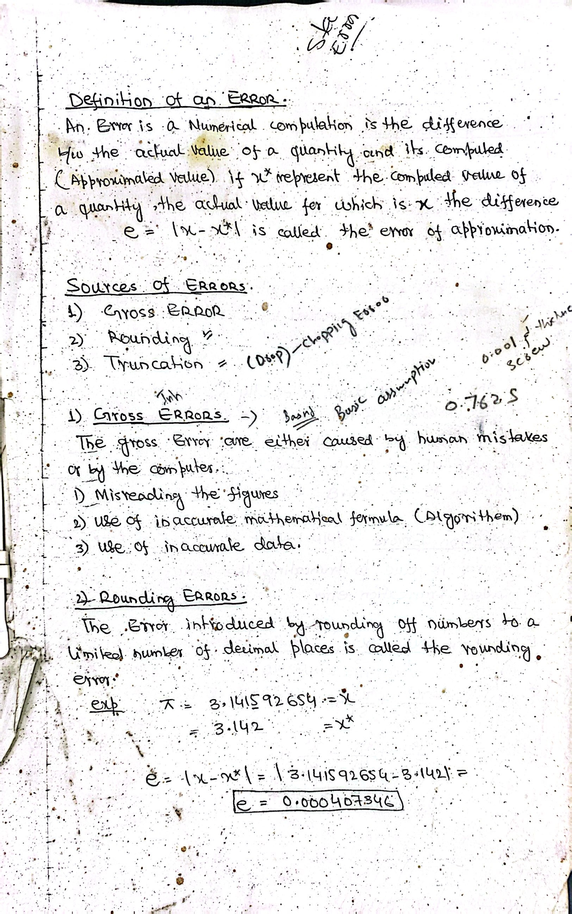

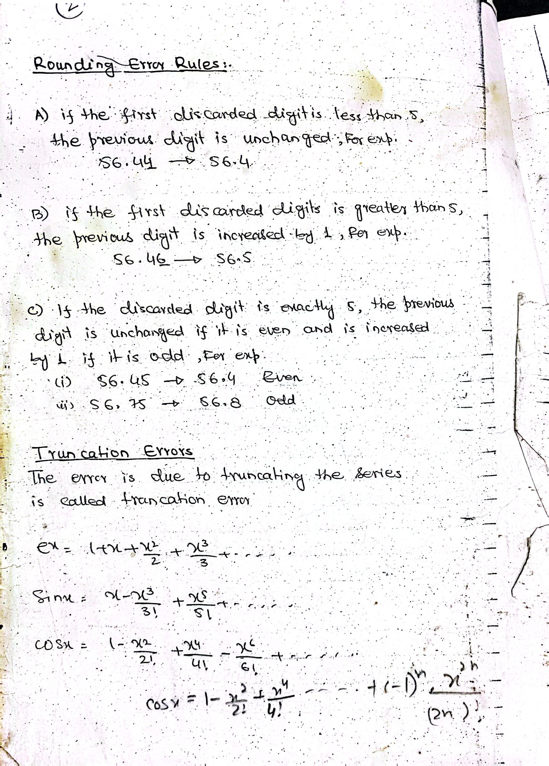

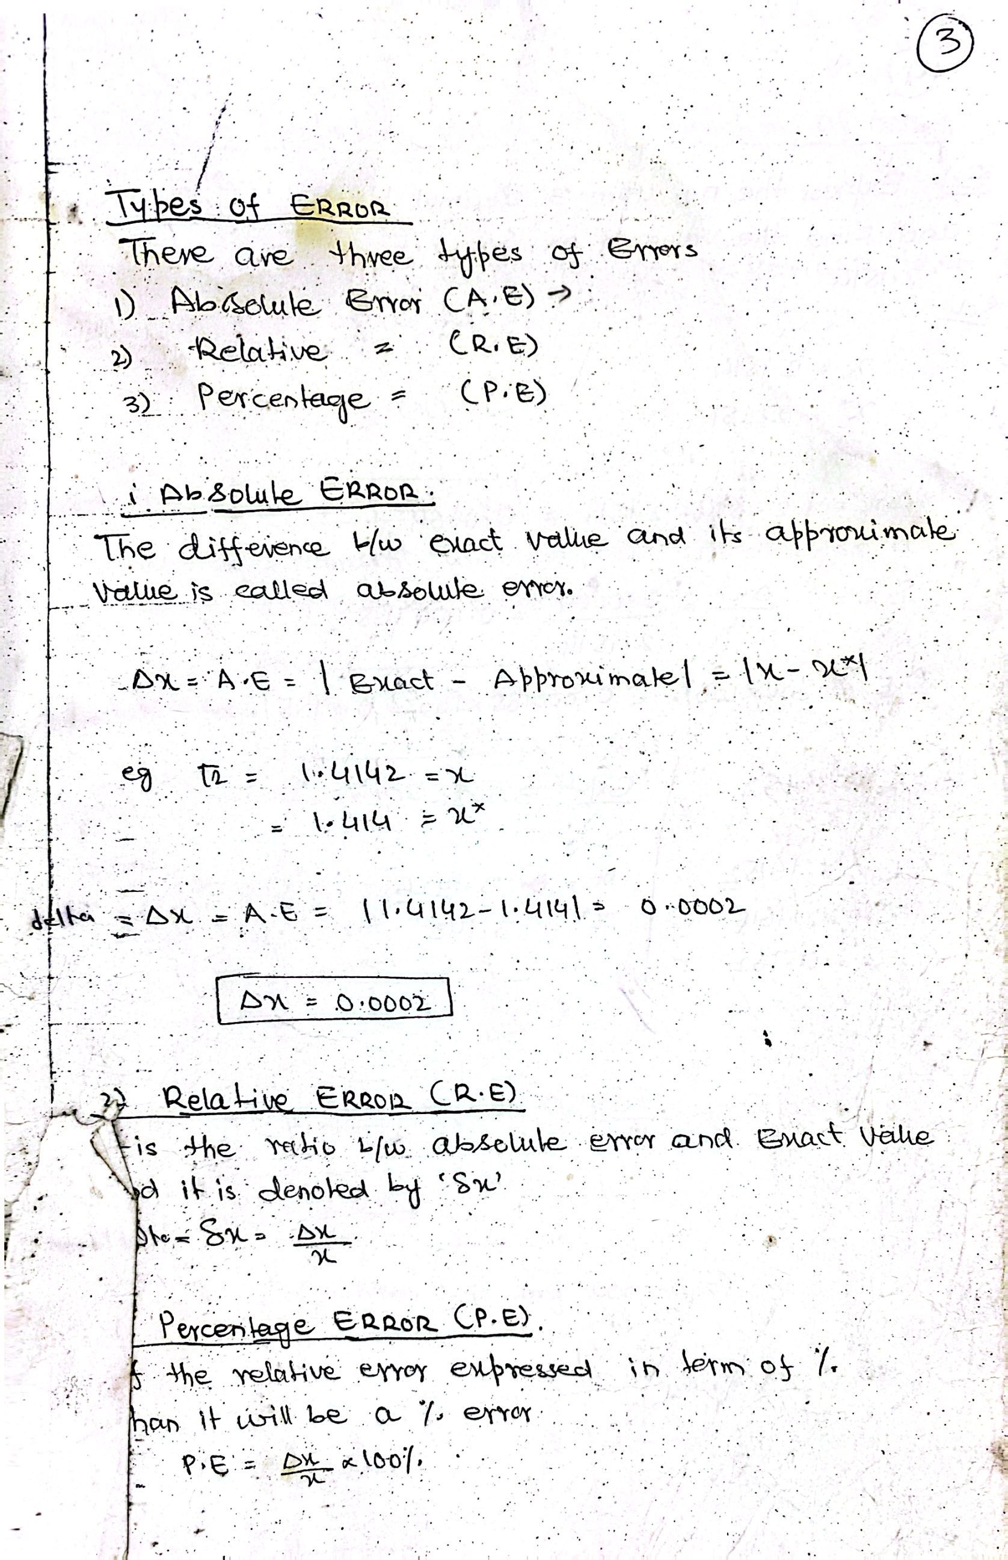

Chapter 1 Error

What is an Error in Numerical Analysis?
In numerical analysis, an error is the difference between the true/exact value and the computed/approximated value of a quantity. It reflects the inaccuracy introduced by numerical methods due to limitations like finite precision, approximations, and computational procedures.
Error=True Value−Computed Value

Applications in Computer Science:
Errors and their analysis are crucial in various computer science areas:
- Scientific Computing
Used in simulations (e.g., weather forecasting, physics modeling) where small errors can accumulate and affect outcomes.
- Computer Graphics
Approximations in rendering and transformations often involve round-off and truncation errors.
- Machine Learning and AI
Loss functions are based on error measurements (e.g., Mean Squared Error) to optimize models.
- Cryptography and Numerical Algorithms
Precise calculations are critical, and error analysis helps ensure stability and accuracy.
- Embedded Systems and Real-Time Systems
Sensor inputs and floating-point arithmetic introduce errors; systems must be designed to tolerate or correct them.
- Software Engineering
Numerical methods are used in algorithms where approximations (e.g., root finding, matrix operations) are required.

Why It Is Used:
- To evaluate accuracy of numerical methods and algorithms.
- To choose suitable algorithms that minimize or control error.
- To ensure reliability of computational results in scientific, financial, and engineering applications.
- To detect instability or divergence in iterative processes.
- To optimize performance by balancing between speed and acceptable precision.

Chapter 4

Why Optimization is Used in Numerical Analysis
Optimization in numerical analysis refers to the process of finding the best solution (maximum or minimum) for a problem under given constraints. It’s used because many real-world problems require determining the most efficient, cost-effective, or accurate solution from a set of possibilities.

Why It Is Used:
- Resource Efficiency: To minimize time, cost, or energy consumption.
- Accuracy Improvement: To minimize error in numerical models.
- Decision Making: To find the best course of action among alternatives.
- Problem Solving: Many scientific and engineering problems are naturally optimization problems (e.g., minimizing stress on a bridge).

Applications in Computer Science:
Area | Application of Optimization
Machine Learning & AI | Training models by minimizing loss functions (e.g., gradient descent)
Operating Systems | Process scheduling, memory management (e.g., minimizing turnaround time)
Computer Networks | Optimizing routing paths to minimize latency or maximize throughput
Software Engineering | Code optimization for performance and memory usage
Computer Vision | Image enhancement, object detection by optimizing feature matching
Game Development | Pathfinding (e.g., A* algorithm), AI decisions using utility optimization
Database Systems | Query optimization for faster data retrieval
Cybersecurity | Minimizing risk or maximizing detection accuracy in intrusion systems

1st-Order Method: Gradient Descent
- Uses: First derivative (gradient) of the function.
- Idea: Moves in the direction of steepest descent (negative gradient).
- Computation Cost: Low (only requires gradient).
- Speed: Slower convergence, especially near the minimum.
- Memory Usage: Efficient; suitable for large-scale problems.
- Example: xnew​=xold​−α∇f(x)

2nd-Order Method: Newton’s Method (uses Hessian Matrix)
- Uses: First and second derivatives (gradient + Hessian matrix).
- Idea: Uses curvature information to find a better direction and step size.
- Computation Cost: High (Hessian is expensive to compute and invert).
- Speed: Faster convergence, especially near the minimum.
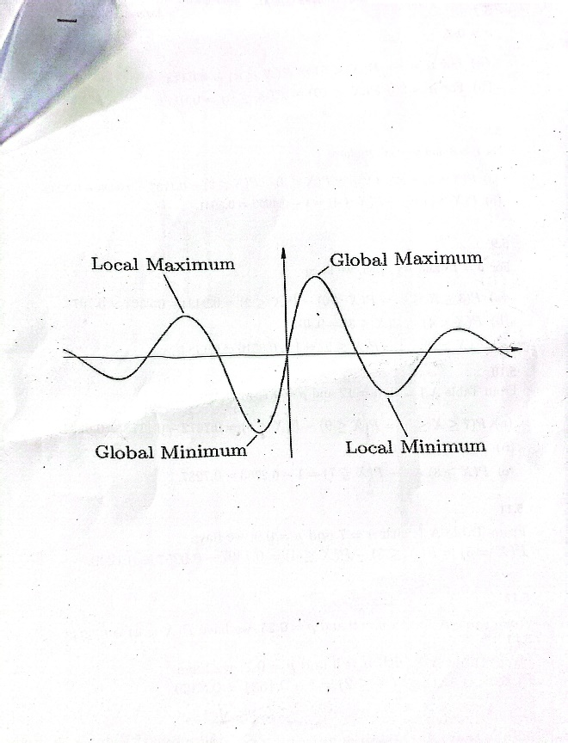
- Memory Usage: High; not ideal for high-dimensional data.
- Example:
x_{new}​=x_{old}​−H−1∇f(x)
where H is the Hessian matrix (matrix of second partial derivatives).

1. Minima (Minimum):
A minimum of a function is a point where the function value is less than or equal to the values at nearby points.
- Local Minimum: A point where the function has the lowest value in a small region.
- Global Minimum: A point where the function has the lowest value over its entire domain.

2. Maxima (Maximum):
A maximum of a function is a point where the function value is greater than or equal to the values at nearby points.
- Local Maximum: A point where the function has the highest value in a small region.
- Global Maximum: A point where the function has the highest value over its entire domain.
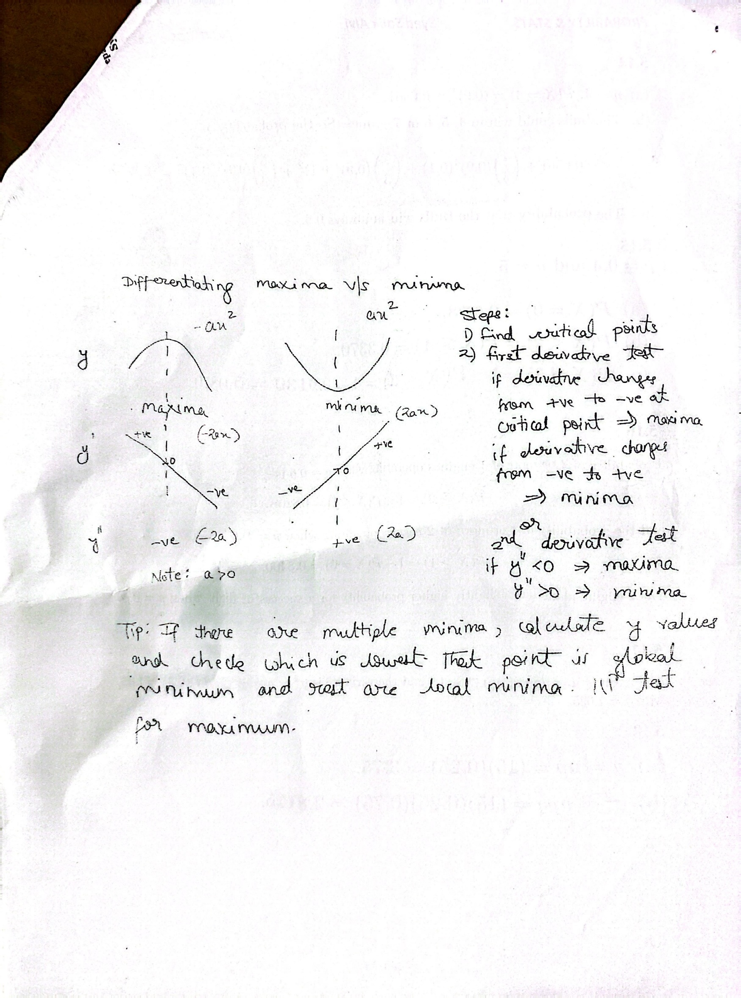





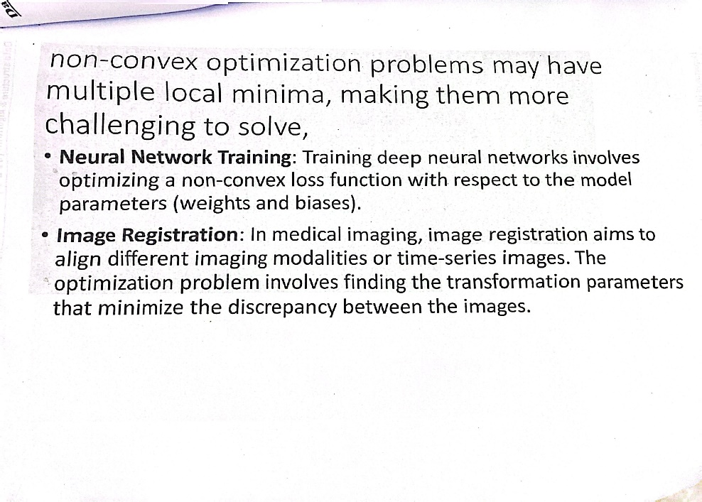
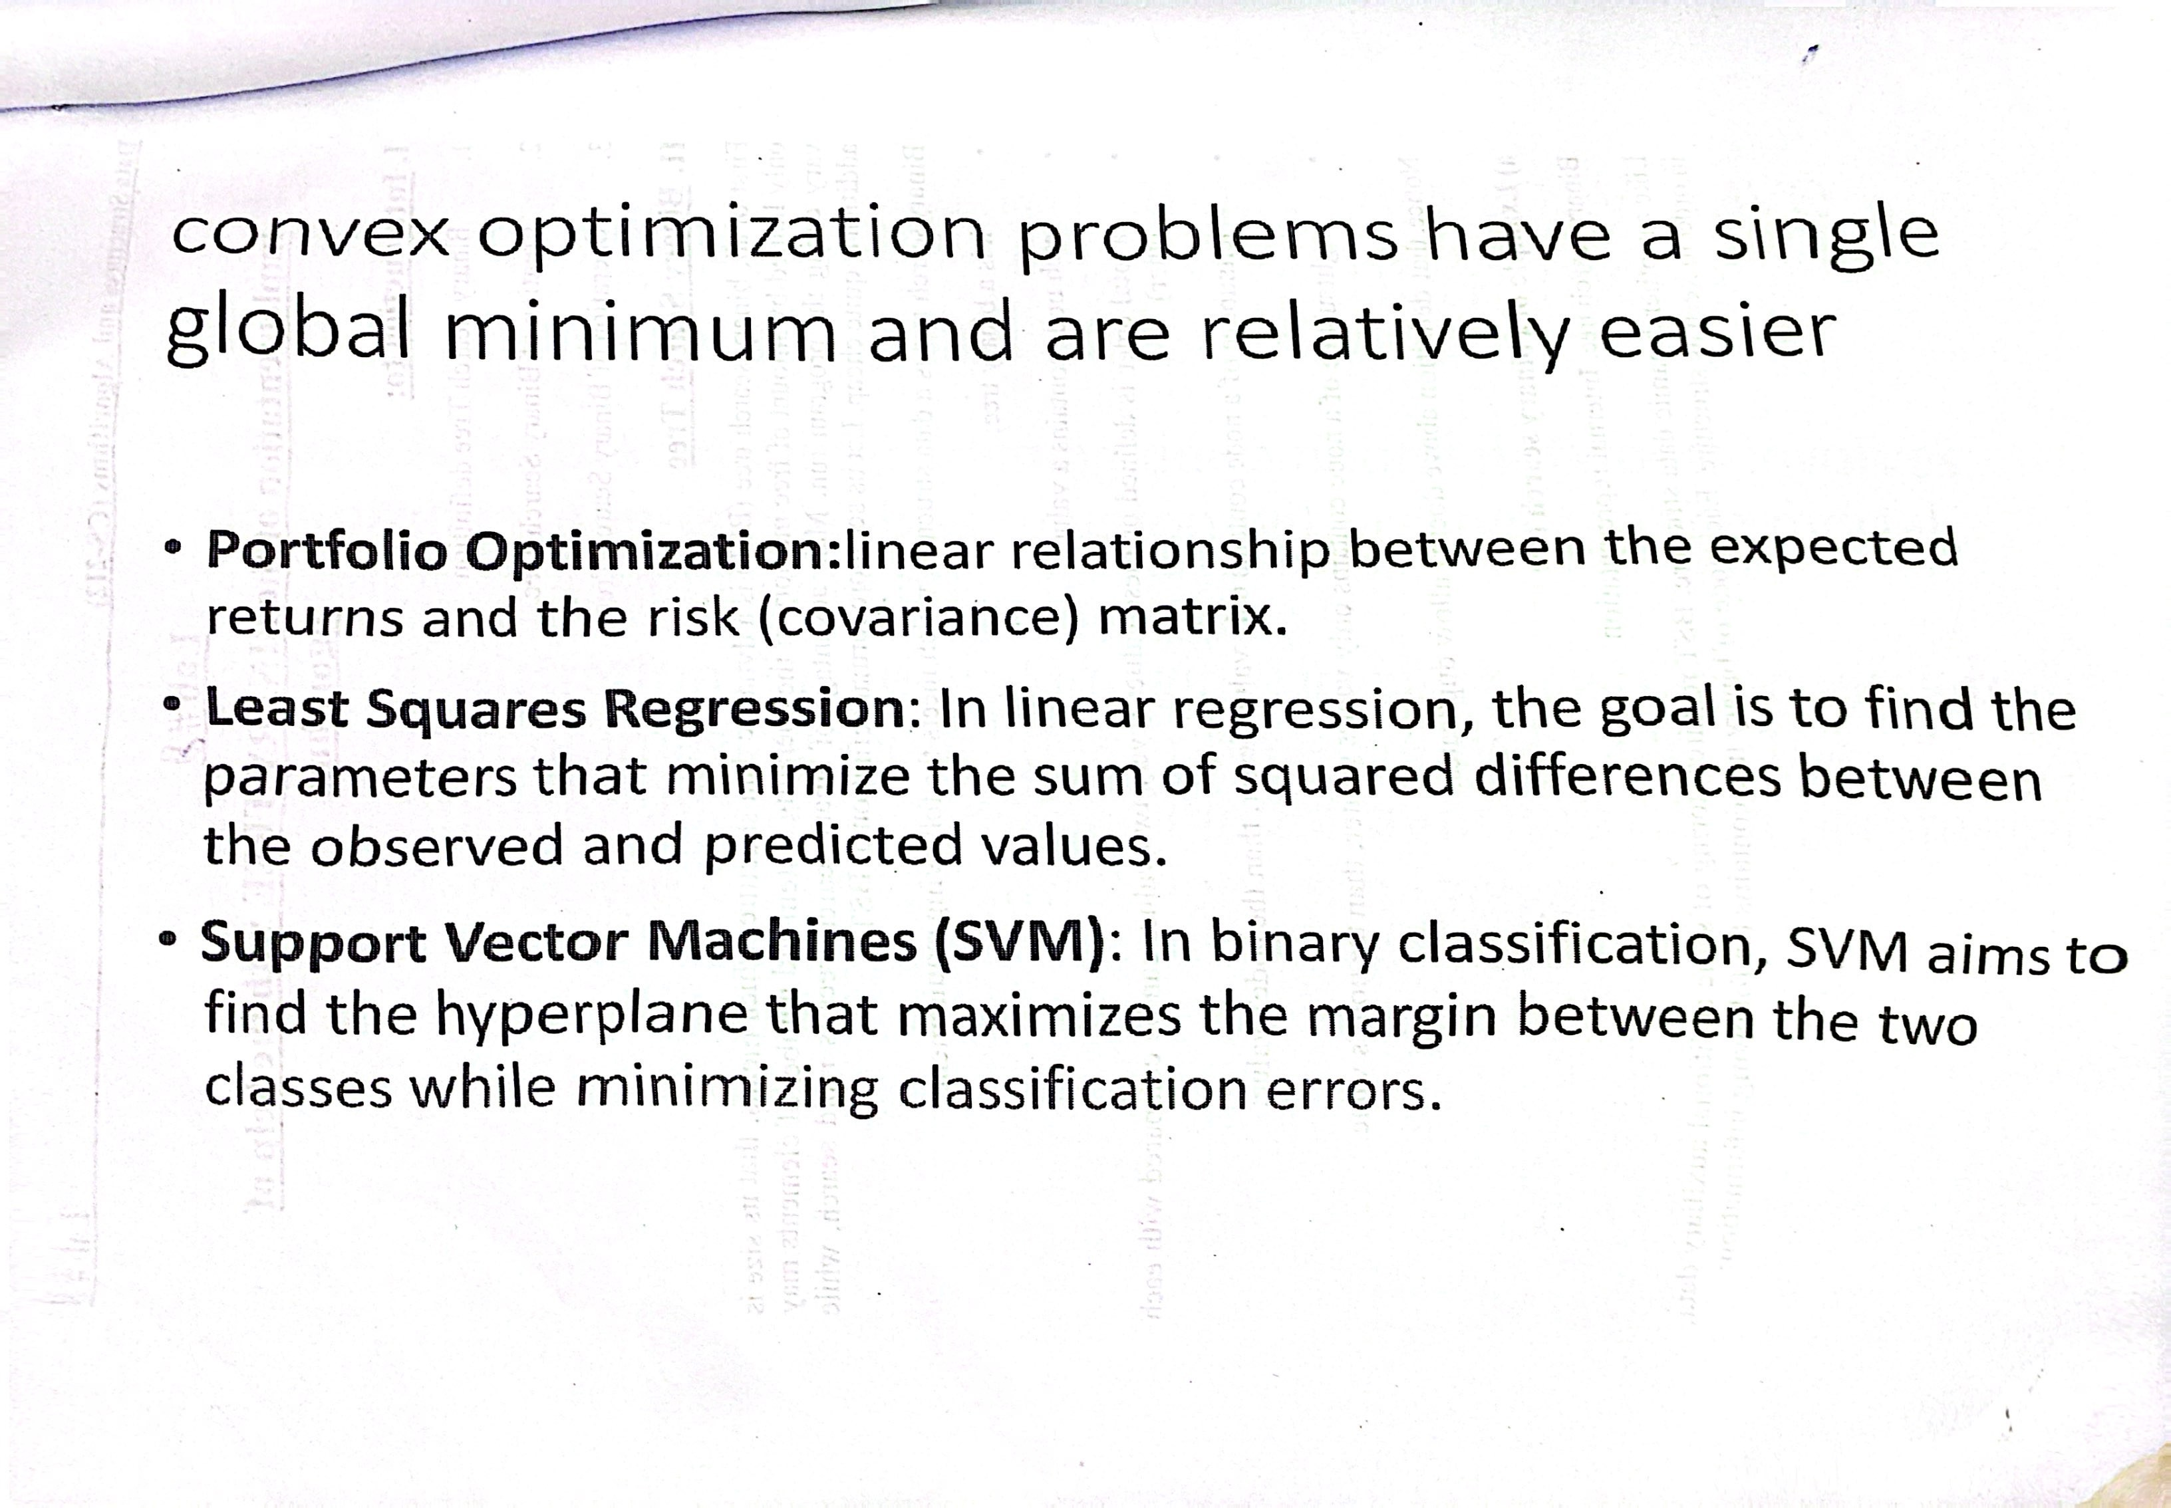

Chapter 5 Interpolation
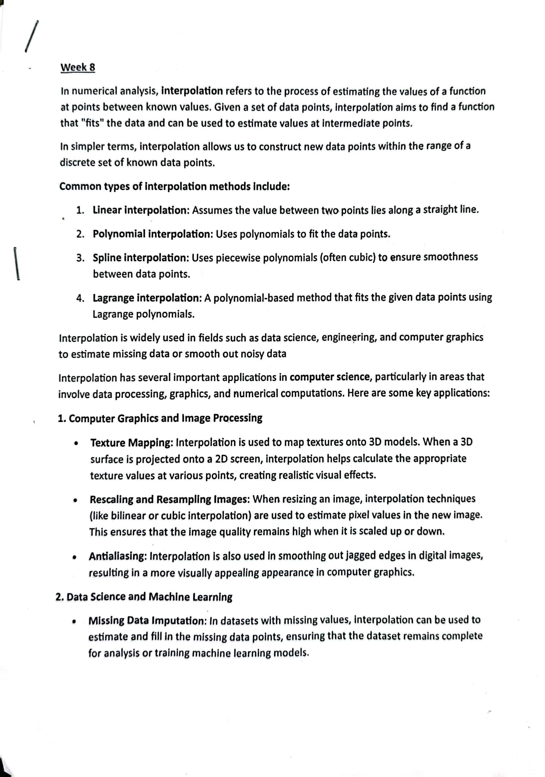



- Computer Graphics and Image Processing
  - Texture Mapping
  - Rescaling and Resampling Images
  - Antialiasing

- Data Science and Machine Learning
  - Missing Data Imputation

3. Numerical Methods
- Solving Differential Equations
- Numerical Integration and Differentiation

4. Game Development and Physics Simulations
- Pathfinding Algorithms
- Simulation

5. Geographic Information Systems (GIS)
- Terrain Mapping and Modeling
- Weather Forecasting

6. Animation and Motion Capture
- Smooth Animation Transitions
- Motion Blending

7. Signal Processing
- Signal Reconstruction

8. CAD (Computer-Aided Design) and CAM (Computer-Aided Manufacturing)
- Curve Fitting and Surface Modeling

9. Cryptography
- Elliptic Curve Cryptography (ECC)

10. Compression Algorithms
- Data Compression
